**MODULE-1**

1 ) What is SDLC ?

-SDLC (software development life cycle ) its describe structure of phase or step of any software. It is the provide a model for the development and lifecycle for the management of an application or product of structure.

2) what is agile methodology?

- Agile methodology is a combination of iterative and incremental models with focus on process adaptability and customer satisfaction by rapid delivery of working software product.

3) What is SRS ?

- (software requirements specification) is a complete description of the behavior of the system to be developed.

4) what is OOPS ?

- (Object oriented programming systems) is a programming Language style or model organized around objects rather than action and data rather than logic.

5) Write basic concepts of opps ?

- There are six concepts of oops -Objects , Class ,Encapsulation ,Inheritance ,Polymorphism

and Abstraction.

6) What is object ?

- An objects represents an individual , identifiable item,unit or entity,either real abstract,with a well-defined role in the problem domain.

7) What is class ?

- A class represents an abstraction of the objects and abstracts the properties and behavior of that object.

8) what is encapsulation ?

- Encapsulation is the practice of including in an objects everything it needs hidden from other objects.

9) What is inheritance ?

- Inheritance means that the one class inherits the characteristics of another class.This is also called a “it a” relationship.

10 ) What is polymorphism ?

- Polymorphism is the ability of different objects to respond in a unique way to the same message.

11) What is RDBMS ?

-The software used to store, manage, query, and retrieve data stored in a relational database is called a relational database management system (RDBMS).

12) What is SQL ?

- ( Structure Query Language) A join clause is used to combine rows or more table based on a related to Colum between them.

13) Write SQL commands ?

-DDL – Data Definition Language

DML – Data Manipulation Language

DCL – Data Control Language

DQL – Data Query Language

14 ) Draw usecase on online book shopping ?

* 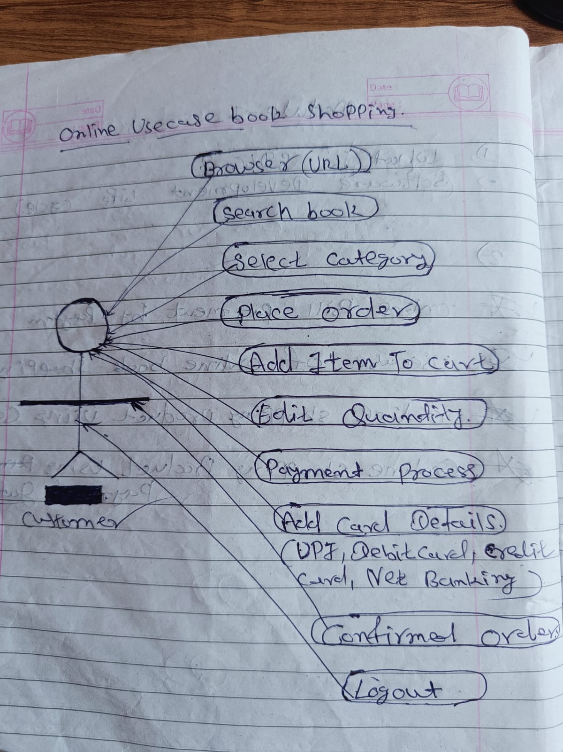

15 ) Draw usecase on online bill payment system (paytm) ?

* 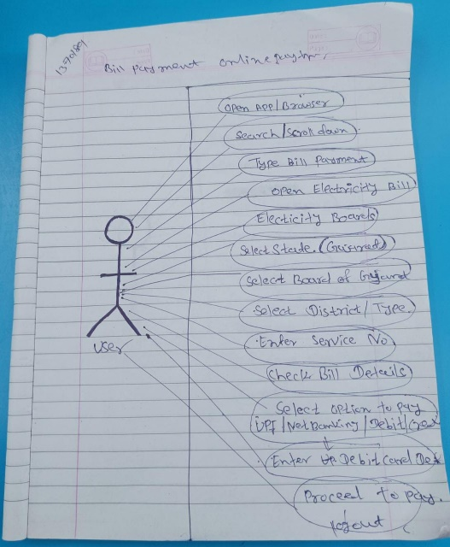

16 ) Write SDLC phase with basic introduction ?

-SDLC phase a per below details.

**Requirements Gathering –I**is the process of identifying your project's exact requirements from start to finish.There is to type of requirements (1) Functional requirements (2) Non-functional Requirements.

**Analysis-**The analysis phase defines the requirements of the systems, independent of how these requirements will be accomplished.

**Design-** The design phase is a stage where software developers define the technical details of the product. The design team can now expand upon the information established in the requirement document.

**Implementation-**In the implementation phase.the team builds the components either from scratch or by composition.

**Testing-** In the testing is done to ensure that the entire application works according to the customer requirements. After testing, the QA and testing team might find some bugs or defects and communicate the same with the developers.

**Maintenance-** Software maintenance is one of the activities in software engineering,and is the process of enhancing and optimizing deployed software (software release), as well as fixing defects.

17 ) Write agile manifesto principles ?

-**Individuals and interactions** **-** in agile development,self-organization and motivation are important,as are interactions like co-location and pair programming.

**Working software –** demo working software is considered the best means of communication.

**Customer collaboration -** as the requirement cannot be gathered completely in the beginning of the project due to various factors,continuous customer interaction is very important to get proper product requirements.

**Responding to change –** agile development is focused on quick responses to change and continuous development.

18 ) What is joins ?

-A join clause is used to combine rows from two or more tables,based on a related column between them.

19 ) Write type of joins ?

-**INNER JOIN :** return rows when there is a match in both tables.

**LEFT JOIN :** returns all rows from the left table, even if there are no matches in the right table.

**RIGHT JOIN :** returns all rows from the right table, even if there are no matches in the left table.

**FULL JOIN :** returns rows when there is a match in one of the tables.

20 ) Explain working methodology of agile model and also write pros and cons.

- Agile model is a combination of iterative and incremental process models with focus on process adaptability and customer satisfaction by rapid delivery of working software product.

**PROS :**

-Realistic,

-Teamwork & cross training,

-Functionality, rapidly and demonstrated,

-Requirements are minimum,

-Collabaration,flexibility,documentation,

-Timely delivers,easy to manage.

**CONS :**

**-**Not suitable for handling,

-Risk of sustainability,maintainability and extensibility,

-Project management,overall planned,

-Delivery management,scope,functionality & adjustments,deadlines,

-Customer interactions,customer is not clear,

-High dependency,lack of documentation,

-Goal focus shifting,challenging.

21 ) Draw usecase on online shopping product using COD ?

* 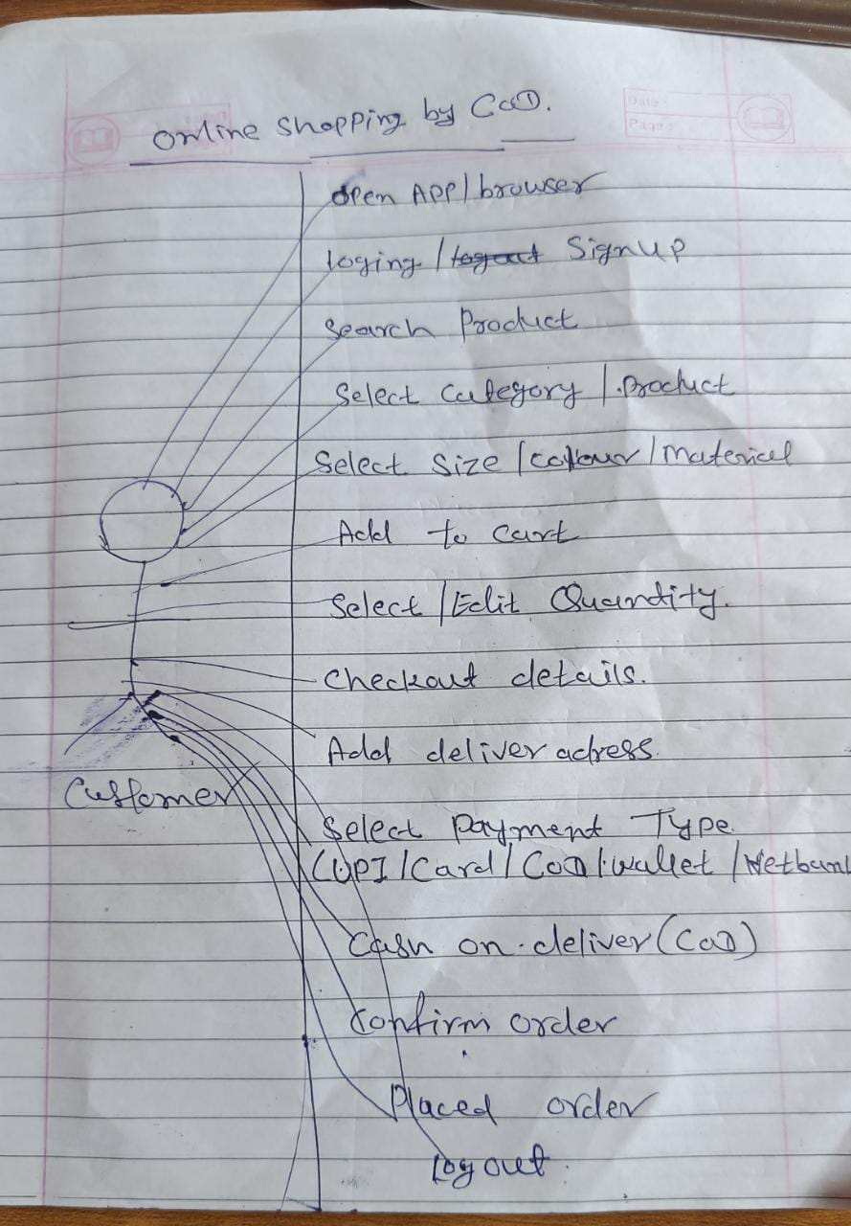

22 ) Draw usecase on online shopping product using payment gateway ?

* 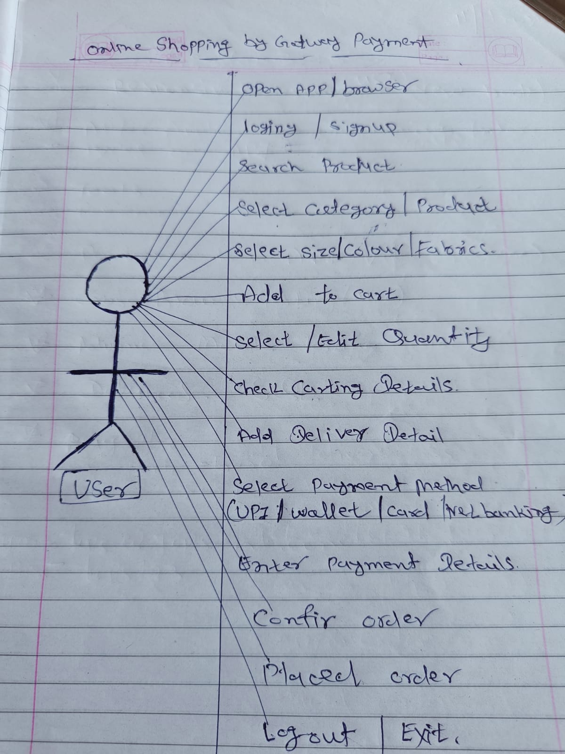

23 ) Write phases of the waterfall model ?

-This model phase are – Requirements analysis,Designs,Implementation,Testing and Maintenance.

24 ) Write phase of spiral model ?

- Planing,Risk analysis,Customer evaluation,Engineering.